# Extra Credit

**Compare the performance of KNN and LinReg in this task. The instructor anticipates that LinReg might work well. If that turns out to be the case, how can that be? This is a non-linear task.**

In my test, KNN learner performed better than Linear Regression learner. I can see that for some stocks, Linear Regression learner could potentially perform better because of the nature of learning methods. KNN learning method is good to identify groups/clusters of data by its nature. On the other hand Linear Regression fits a line to data at slope it is heading using training data. So in my opinion, Linear Regression learner could outperform KNN learner for stocks that are less volatile.

**KNN**

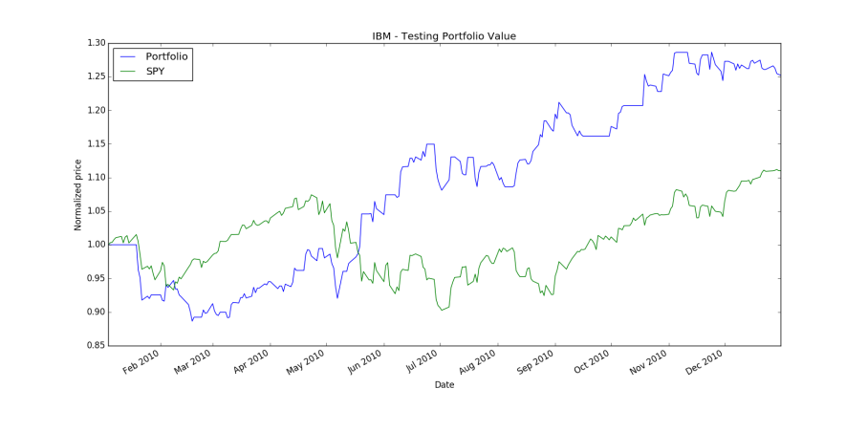

**Linear Regression**

